CREATE TABLE CUSTOMER(CID INT PRIMARY KEY NOT NULL,

CNAME NVARCHAR(30),

CADDRESS NVARCHAR(50),

CCITY VARCHAR(20));

CREATE TABLE ACCOUNT(ANO INT PRIMARY KEY NOT NULL,

ATYPE VARCHAR(15),

CID INT FOREIGN KEY REFERENCES CUSTOMER(CID),

BALANCE MONEY);

CREATE TABLE "TRANSACTION"(TID INT PRIMARY KEY NOT NULL,

ANO INT FOREIGN KEY REFERENCES ACCOUNT(ANO),

TTYPE VARCHAR(15),

TDATE DATE,

TAMOUNT MONEY);

INSERT INTO CUSTOMER VALUES(100,'Leena','Anna nagar','chennai');

INSERT INTO CUSTOMER VALUES(101,'Kannappan','Periyar Nagar','Sivagangai');

INSERT INTO CUSTOMER VALUES(102,'Masood','Papa nagar','Virudhunagar');

INSERT INTO CUSTOMER VALUES(103,'Gowtham','Edward Colony','Coimbatore');

INSERT INTO CUSTOMER VALUES(104,'Priya','Nehru nagar','Virudhunagar');

INSERT INTO CUSTOMER VALUES(105,'Nisha','Gandhi nagar','Krishnagiri');

INSERT INTO ACCOUNT VALUES(123,'Savings',100,150000);

INSERT INTO ACCOUNT VALUES(345,'Check',101,20000);

INSERT INTO ACCOUNT VALUES(321,'Savings',102,25000);

INSERT INTO ACCOUNT VALUES(456,'Savings',103,30000);

INSERT INTO ACCOUNT VALUES(678,'Check',100,10000);

INSERT INTO ACCOUNT VALUES(901,'Savings',105,900000);

INSERT INTO "TRANSACTION" VALUES(1000,123,'Withdraw','2023-03-19',10000);

INSERT INTO "TRANSACTION" VALUES(1001,345,'Deposit','2023-03-19',1500);

INSERT INTO "TRANSACTION" VALUES(1002,321,'Withdraw','2022-05-29',14200);

INSERT INTO "TRANSACTION" VALUES(1003,456,'Withdraw','2021-10-30',2500);

INSERT INTO "TRANSACTION" VALUES(1004,678,'Deposit','2020-9-29',5000);

INSERT INTO "TRANSACTION" VALUES(1005,901,'Deposit','2023-02-19',530000);

1. SELECT ANO,BALANCE FROM ACCOUNT WHERE ANO=123;

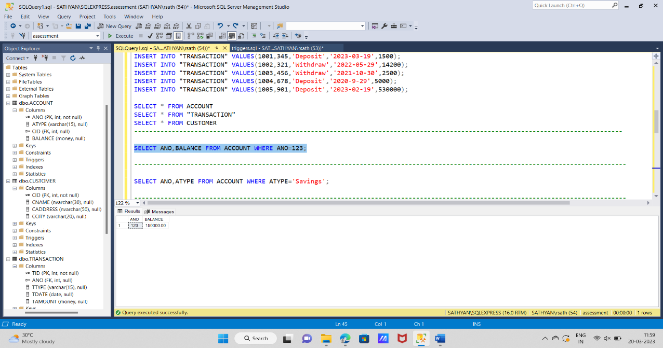

1. SELECT ANO,ATYPE FROM ACCOUNT WHERE ATYPE='Savings';

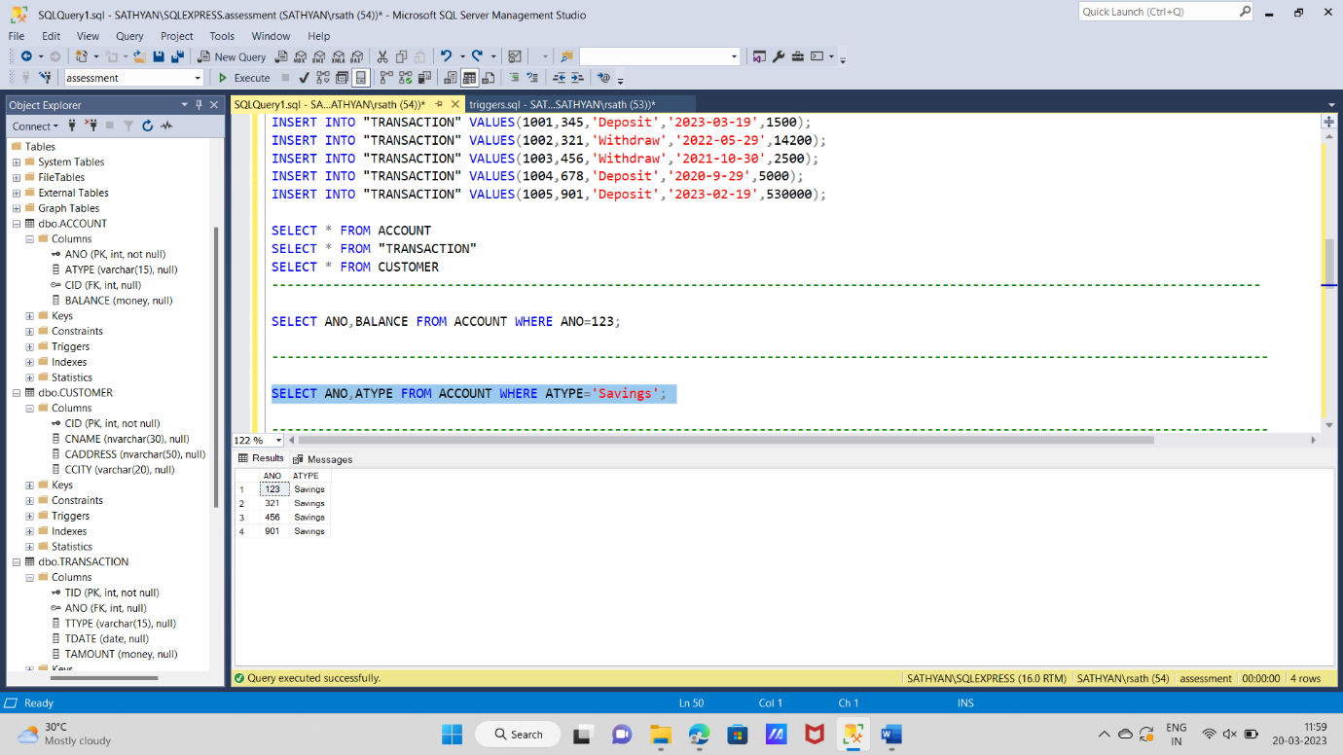

1. SELECT * FROM CUSTOMER WHERE CCITY='Virudhunagar';

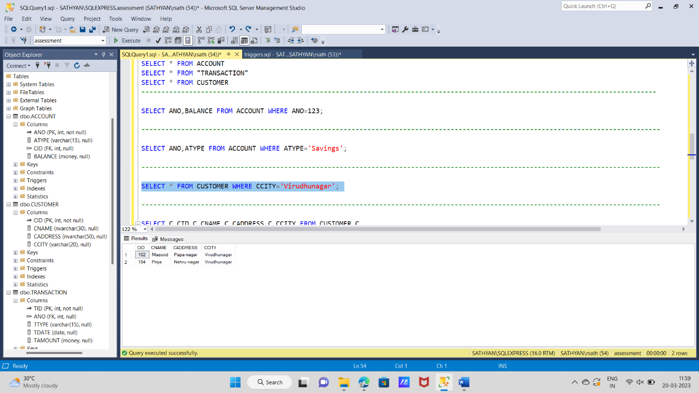

1. SELECT C.CID,C.CNAME,C.CADDRESS,C.CCITY FROM CUSTOMER C

INNER JOIN ACCOUNT A ON C.CID=A.CID

INNER JOIN "TRANSACTION" T ON T.ANO=A.ANO

WHERE T.TDATE= DATEADD(day, -1, CAST(GETDATE() AS date));

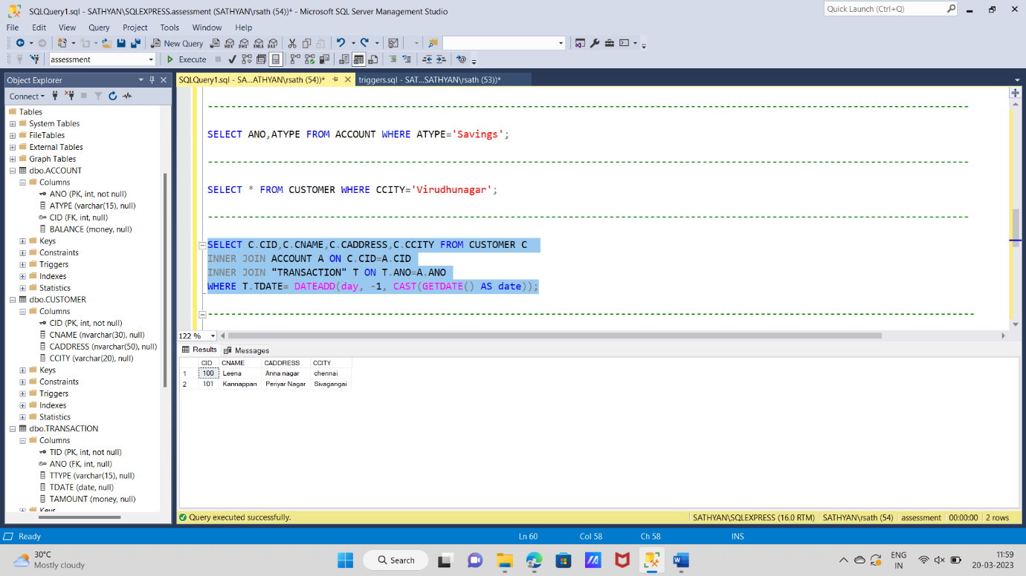

5) CREATE OR ALTER TRIGGER trans_trigg ON "TRANSACTION"

FOR INSERT

AS

BEGIN

Declare @ins_amt money

Declare @ins_acno bigint

Declare @ins_ttype nvarchar(8)

SELECT @ins_amt = TAmount from inserted

SELECT @ins_acno = Ano from inserted

SELECT @ins_ttype = ttype from inserted

if @ins_ttype = 'deposit'

update Account set balance = balance + @ins_amt where Ano = @ins_acno

else

update Account set balance = balance - @ins_amt where Ano = @ins_acno

END

INSERT INTO "TRANSACTION" VALUES(1006,345,'Deposit','2023-02-19',5000);

SELECT BALANCE FROM ACCOUNT WHERE ANO=345;

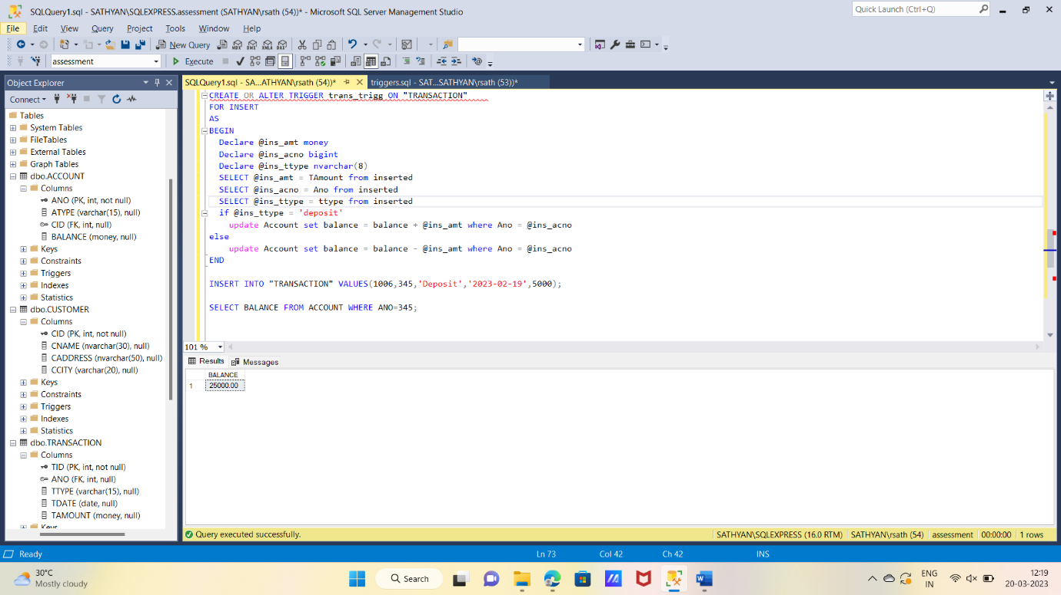

6)

CREATE OR ALTER Function CITY(@name nvarchar(25))

Returns nvarchar(25)

AS

BEGIN

DECLARE @city nvarchar(25)

Select @city = ccity from customer where cname = @name

Return @city

END

select dbo.CITY('leena') AS CITY

